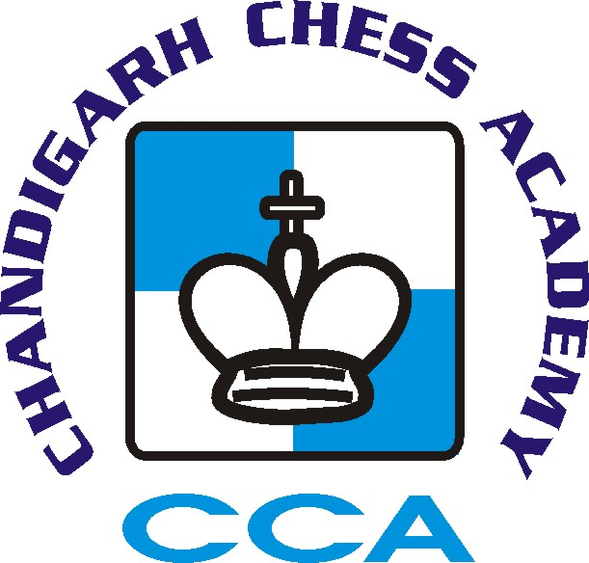

1st St. Xavier’s (Below 2000) All India Open FIDE Rating Chess Tournament 2013
(Recognized by AICF)
(AICF Event Code: 87107/CHA/2013)

21st to 24th December 2013

Organised by
Chandigarh Chess Academy
(Affiliated to Chandigarh Chess Association)
Under the auspices of All India Chess Federation

Venue

St. Xavier’s Sr. Secondary School Sector 44-C, Chandigarh.

Tournament Schedule

Arrival Time | 11:00 AM | 21/12/2013
Opening Ceremony | 12:00 noon | 21/12/2013
Players Meeting | 1:00 PM | 21/12/2013
Round 1 | 1:30 PM | 21/12/2013
Round 2 | 5:00 PM | 21/12/2013
Round 3 | 9:00 AM | 22/12/2013
Round 4 | 1:00 PM | 22/12/2013
Round 5 | 5:00 PM | 22/12/2013
Round 6 | 9:00 AM | 23/12/2013
Round 7 | 1:00 PM | 23/12/2013
Round 8 | 5:00 PM | 23/12/2013
Round 9 | 9:00 AM | 24/12/2013
Closing Ceremony | 2:00 PM | 24/12/2013

Cash Prizes

1st Prize – Rs. 21,000/- + Trophy,
2nd Rs.15,000/-,

3rd Rs. 11,000/-,
4th Rs.7000/-,
5th Rs. 6000/-,
6th Rs. 5000/-,
7th Rs. 4000/-,
8th Rs. 3000/-,
9th Rs.2000,
10th to 14th Rs. 1500/- each,
15th to 20th Rs. 1100/- each.

Category Prizes

Best Unrated Rs. 1000/-, Best Women Rs. 1000/-
Best Veteran (Above 50 yrs) Rs. 1000/-
Note: Player has to score minimum 4 points for the above category.

Age Group Prizes

Best Under-15 Boy Rs. 1100/-, Best Under-15 Girl Rs. 1100/-
Best Under-10 Boy Rs. 1100/-, Best Under-10 Girl Rs. 1100/-

Age Group Prizes for Chandigarh Players

Best Chandigarh Women Player Rs. 900/-
Best Chandigarh Under-15 Boy Rs. 900/-
Best Chandigarh Under-15 Girl Rs. 900/-
Best Chandigarh Under-10 Boy Rs. 900/-
Best Chandigarh Under-10 Girl Rs. 900/-
- Cash prizes will not be shared on same points
- One Player will be given one prize only.
- Age proof certificates are necessary to claim age group prizes.

Entry Fee Rs. 1000/-

Last Date of Entry : 19-12-2013
Entry Details

- Entry for Chandigarh Players is Rs. 900.
- Entries must be deposited by 19th Dec, 2013 thereafter a late fee of Rs. 200/- will be charged till 21st Dec 2013.
- Entries should be sent by DD in favor of “Chandigarh Chess Academy” payable at Chandigarh.
- Entry fee can also be transferred to A/C No. 60060371863 of Bank of Maharashtra, IFSC Code: MAHB0001296 and please send the transfer slip via Email to nbansal99@yahoo.com.

Address for sending entries :

Mr. Naveen Bansal, Founder Director, Chandigarh Chess Academy
House No. 2626, Sector-37 C, Chandigarh-160036 Mobile : 09417148610,
Email: nbansal99@yahoo.com

Lodging

- Out station players should make their own lodging arrangements.
- Lodging arrangements in hotels/bhavan can be arranged on payment basis from 21th to 24th Dec, 2013.
- Hotels/Bhavan are at a walking distance from venue.

Lodging Charges

- Non A/C Accommodation in Sood Bhavan on double sharing basis Rs. 1000/- per person from 21st to 23rd Dec. 2013.

Note: Those who require accommodation should pay the amount along with Entry Fee before 10th December, 2013. Accommodation will be provided on first come first serve basis.

AICF Registration

All India Chess Federation Registration for the year 2013 is compulsory for all the participants and proof should be enclosed/shown to the organizers. AICF Registration can be done at the venue by paying Rs.250/-.

CCA Registration

Chandigarh Chess Association registration is compulsory for Chandigarh players. Unregistered players can register at the venue by paying Rs. 50/-

Rules :
- 9 Rounds Swiss League
- Time control will be 60 Minutes plus 30 second increment from move 1.
- Buchholz Tie- Break System will be applied.
- Appeal Committee of 5 members with 2 reserves amongst the senior participants official present at players meeting shall be formed before the commencement of the tournament. All the members and reserves will be from different states. No member of the committee can vote on dispute in which a player from his state is involved and in such case reserve members shall take his place in the committee.
- In case of dispute the Tournament Director’s decision will be final and binding on all.
- Protest have to be lodged in writing within 30 minutes of the occurrence of the incident along with a fee of Rs. 500/- which shall be refunded only if the protest is upheld.
- The decision of the appeal committee/ Chief Arbiter will be final and binding on all the players.
- The organisers of the tournament have the right to accept or reject any entry fee without giving any reason.
- The organisers of the tournament reserve the right to make necessary changes in rules pertaining to the tournament.
- Smoking/Drinking is strictly prohibited in the school premises.

Organising Committee

Dr. Vipnesh Bhardwaj : 098146-15100 (Chairperson, Chandigarh Chess Academy)
Mr. Naveen Bansal : 094171-48610 (Founder Director, Chandigarh Chess Academy)

Website : www.chessinchandigarh.com
Email : nbansal99@yahoo.com, vipneshb@gmail.com

No request towards the waiver of entry fee or late fee will be entertained.
Players are requested to bring their own Chess Clocks.

