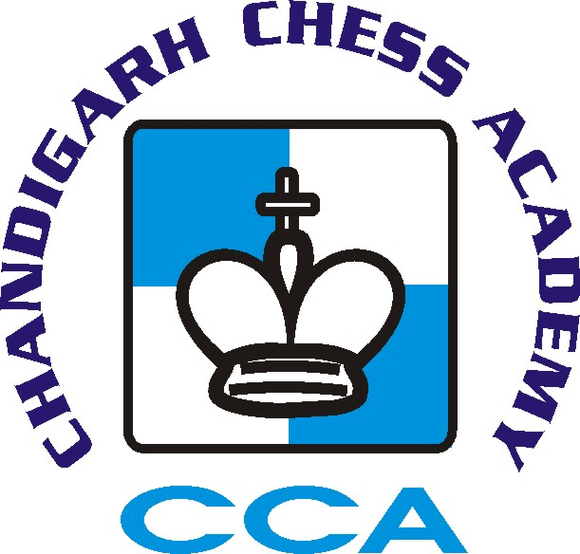

1st CHITKARA INTERNATIONAL SCHOOL FIDE Rating Chess Championship 2016
(02nd to 06th January 2016)

(Recognized by AICF)
‘B’ CATEGORY

1st CHITKARA INTERNATIONAL SCHOOL ALL INDIA BELOW 1600 FIDE RATING CHESS CHAMPIONSHIP 2016
AICF Event Code: 124202/CHAN/2015

‘A’ CATEGORY

1st CHITKARA INTERNATIONAL SCHOOL ALL INDIA OPEN FIDE RATING CHESS CHAMPIONSHIP 2016
AICF Event Code: 124201/CHAN/2015

Organised by
Chandigarh Chess Academy
(Affiliated to Chandigarh Chess Association)
Under the auspices of All India Chess Federation

Sponsored by:
http://www.chitkaraschool.in/

VENUE
CHITKARA INTERNATIONAL SCHOOL Sector 25 (West), Chandigarh 160 014, India.

TOURNAMENT SCHEDULE
Arrival Time | 4:00 PM Onwards | 01/01/2016 | Friday
Opening Ceremony | 10:00 AM | 02/01/2016 | Saturday
Players Meeting | 11:00 AM | 02/01/2016 | Saturday
Round 1 | 11:30 AM | 02/01/2016 | Saturday
Round 2 | 4:30 PM | 02/01/2016 | Saturday
Round 3 | 9:30 AM | 03/01/2016 | Sunday
Round 4 | 3:30 PM | 03/01/2016 | Sunday
Round 5 | 9:30 AM | 04/01/2016 | Monday
Round 6 | 3:30 PM | 04/01/2016 | Monday
Round 7 | 9:30 AM | 05/01/2016 | Tuesday
Round 8 | 3:30 PM | 05/01/2016 | Tuesday
Round 9 | 9:00 AM | 06/01/2016 | Wednesday
Closing Ceremony | 4:00 PM | 06/01/2016 | Wednesday

‘A’ CATEGORY

Prize Money(Rs.)
1st | 50,000 (Trophy)
2nd | 30,000
3rd | 15,000
4th | 10,000
5th | 8,000
6th | 6,000
7th | 3,500
8th | 3,000
9th | 3,000
10th | 3,000
11th | 2,500
12th | 2,000
13th | 2,000
14th | 2,000
15th | 2,000
16th | 2,000
Total | 144,000

Rating Category Prizes
 | 1st | 2nd
Below 2000 | 1900 | 1600
Below 1800 | 1900 | 1600
Total |  | 7000

‘B’ CATEGORY

Prize Money(Rs.)
1st | 30,000 (Trophy)
2nd | 20000
3rd | 15000
4th | 10000
5th | 8000
6th | 5000
7th | 3000
8th | 3000
9th | 2500
10th | 2500
11th | 2000
12th | 2000
13th | 2000
14th | 2000
15th | 2000
16th | 2000
17th | 2000
18th | 2000
19th | 2000
20th | 2000
Total | 119,000

Rating Category Prizes
 |  |  | 1st | 2nd | 3rd
Below 1300 |  | Rs. | 1900 | 1500 | 1300
Open Category Prizes
Best Unrated |  | Rs. | 1900 | 1500
Best Veteran (above 60) |  | Rs. | 1900
Best Women Player |  | Rs. | 1700
Best Under 15 Boy |  | Rs. | 1600 | 1400
Best Under 15 Girl |  | Rs. | 1600 | 1400
Best Under 11 Boy |  | Rs. | 1600 | 1400
Best Under 11 Girl |  | Rs. | 1600 | 1400
Chandigarh Category Prizes
Best Chandigarh Women Player |  | Rs. | 1700
Best Chandigarh Under-15 Boy |  | Rs. | 1400
Best Chandigarh Under-15 Girl |  | Rs. | 1400
Best Chandigarh Under-11 Boy |  | Rs. | 1400
Best Chandigarh Under-11 Girl |  | Rs. | 1400
Total |  | Rs. | 31000

Note: Player has to score minimum of 4 points for the above category prizes.

- Cash prizes will not be shared on same points
- One Player will be given one higher prize only.
- Age proof certificates are necessary to claim age group prizes.

ENTRY FEE
Normal | Rs. 1500/-
Chandigarh Players | Rs. 1300/-

Entry Details

Last Date of Entry : 28-12-2015

- There will be discount of Rs.200 on entry fee if received before 10th Dec, 2015.
- Entries must be deposited by 28th Dec, 2015 thereafter a late fee of Rs. 300/- will be charged.
- Entries should be sent by DD in favor of “Chandigarh Chess Academy” payable at Chandigarh.
- For online transfers (NEFT):-
A/C Name: Chandigarh Chess Academy. Bank Name: Bank of Maharashtra.
A/C No. : 60060371863. A/C Type : Current A/C. IFSC Code: MAHB0001296
Note : please send the transfer slip via Email to nbansal99@yahoo.com.

Address for sending entries :

Dr. Vipnesh Bhardwaj, Chairperson,Chandigarh Chess Academy.
House No. 58, Sector-16 A, Chandigarh-160015 Mobile : 09814615100,
Email: nbansal99@yahoo.com, vipneshb@gmail.com

Lodging

- Out station players should make their own lodging arrangements.
- Hotel accommodation on double sharing basis per person from 01st to 05th Jan 2016 will be arranged on payment basis in advance (Hotel Pride Rs. 2000/ Hotel Gobind Palace Rs.1800 from 01st to 05th Jan per person, extra person in a room Rs. 200 with extra mattresses).
- Dormitory Accommodation in Indira Holiday Home per person from 01st to 05th Jan 2016 will be arranged on payment basis in advance.
- Please visit www.chessinchandigarh.com for full details about Hotel Accommodation and Indira Holiday Home accommodation.
.

Note: Those who require accommodation should pay the amount along with Entry Fee before 10th Dec, 2015. Accommodation will be provided on first come first serve basis as per availability.

AICF Registration

All India Chess Federation Registration for the year 2015-16 is compulsory for all the participants and proof should be enclosed/shown to the organizers.

Rules :
- 9 Rounds Swiss League
- Buchholz Tie- Break Systems will be applied.
- Appeal Committee of 5 members with 2 reserves amongst the senior participants official present at players meeting shall be formed before the commencement of the tournament. All the members and reserves will be from different states. No member of the committee can vote on dispute in which a player from his state is involved and in such case reserve members shall take his place in the committee.
- In case of dispute the Tournament Director’s decision will be final and binding on all.
- Protests have to be lodged in writing within 15 minutes of the occurrence of the incident along with a fee of Rs. 500/- which shall be refunded only if the protest is upheld.
- The decision of the appeal committee/ Chief Arbiter will be final and binding on all the players.
- The organisers of the tournament have the right to accept or reject any entry fee without giving any reason.
- The organisers of the tournament reserve the right to make necessary changes in rules pertaining to the tournament.
- The time control will be 90 min + 30 sec increment from move 1 for Category ‘A’ and 60 min + 30 sec increment from move 1 for Category ‘B’.
- Smoking/Drinking is strictly prohibited in the school premises.

Organising Committee

Dr. Vipnesh Bhardwaj : 98146-15100 (Chairperson, Chandigarh Chess Academy)
Mr. Naveen Bansal : 94171-48610 (Founder Director, Chandigarh Chess Academy)
Dr. Anil Raina : 9815232318 (Coordinator)
Mr. Ashish Goyal : 9815507250 (Coordinator)
Mr. Abhijeet Singh: (Coordinator)
Mr. Pushpender Gusain : 9417762157 (Coordinator)
Mr. Vipan Negi : 9855002650 (Coordinator)

Website : www.chessinchandigarh.com
Email : nbansal99@yahoo.com, vipneshb@gmail.com

No request towards the waiver of entry fee or late fee will be entertained.
Players are requested to bring their own Chess Clocks.

